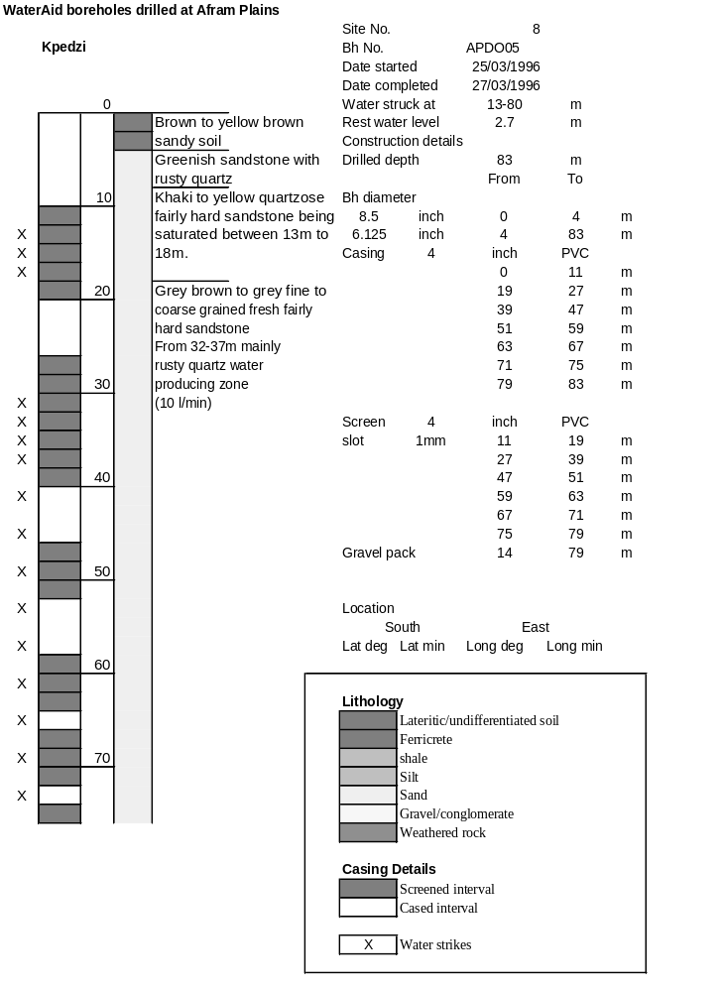

Ghana | Test pumping
Borehole No. |  | APDO5
Hole No |  | 8
Village |  | Kpedzi
Date |  | 13/04/1996
Point above GL |  | 0.5 | m
Pump depth |  | 57 | m
SWL |  | 3.2 | m
Start Time |  | 08:55
Drawdown test |  |  |  |  | Recovery test
time | pwl (m) | Q l/min | dd | sc | Time | wl (m) | s' | t/t'
0.00 | 3.20 | 5.00 | 0.00 |  | 0.00 | 37.61 | 34.41
1.00 | 5.83 | 5.00 | 2.63 | 1.90 | 1.00 | 37.61 | 34.41 | 181.00
2.00 | 5.89 | 5.00 | 2.69 | 1.86 | 2.00 | 37.33 | 34.13 | 91.00
3.00 | 6.20 | 5.00 | 3.00 | 1.67 | 3.00 | 37.05 | 33.85 | 61.00
4.00 | 6.50 | 5.00 | 3.30 | 1.52 | 4.00 | 36.76 | 33.56 | 46.00
5.00 | 6.68 | 5.00 | 3.48 | 1.44 | 5.00 | 36.49 | 33.29 | 37.00
6.00 | 6.81 | 5.00 | 3.61 | 1.39 | 6.00 | 36.20 | 33.00 | 31.00
7.00 | 6.91 | 5.00 | 3.71 | 1.35 | 7.00 | 35.91 | 32.71 | 26.71
8.00 | 7.39 | 5.00 | 4.19 | 1.19 | 8.00 | 35.64 | 32.44 | 23.50
9.00 | 7.63 | 5.00 | 4.43 | 1.13 | 9.00 | 35.36 | 32.16 | 21.00
10.00 | 7.74 | 5.00 | 4.54 | 1.10 | 10.00 | 35.08 | 31.88 | 19.00
11.00 | 7.84 | 5.00 | 4.64 | 1.08 | 12.00 | 34.53 | 31.33 | 16.00
12.00 | 7.90 | 5.00 | 4.70 | 1.06 | 14.00 | 34.02 | 30.82 | 13.86
13.00 | 8.12 | 5.00 | 4.92 | 1.02 | 16.00 | 33.46 | 30.26 | 12.25
14.00 | 8.28 | 5.00 | 5.08 | 0.98 | 18.00 | 32.92 | 29.72 | 11.00
15.00 | 8.38 | 5.00 | 5.18 | 0.97 | 20.00 | 32.37 | 29.17 | 10.00
16.00 | 8.46 | 5.00 | 5.26 | 0.95 | 22.00 | 31.82 | 28.62 | 9.18
17.00 | 8.51 | 5.00 | 5.31 | 0.94 | 24.00 | 31.33 | 28.13 | 8.50
18.00 | 8.62 | 5.00 | 5.42 | 0.92 | 26.00 | 30.80 | 27.60 | 7.92
19.00 | 8.80 | 5.00 | 5.60 | 0.89 | 28.00 | 30.28 | 27.08 | 7.43
20.00 | 9.12 | 5.00 | 5.92 | 0.84 | 30.00 | 29.76 | 26.56 | 7.00
22.00 | 10.40 | 5.00 | 7.20 | 0.69 | 35.00 | 28.47 | 25.27 | 6.14
24.00 | 11.00 | 5.00 | 7.80 | 0.64 | 40.00 | 27.20 | 24.00 | 5.50
26.00 | 11.60 | 5.00 | 8.40 | 0.60 | 45.00 | 25.92 | 22.72 | 5.00
28.00 | 12.46 | 5.00 | 9.26 | 0.54 | 50.00 | 24.64 | 21.44 | 4.60
30.00 | 13.20 | 5.00 | 10.00 | 0.50 | 60.00 | 22.47 | 19.27 | 4.00
35.00 | 15.26 | 5.00 | 12.06 | 0.41 | 70.00 | 20.32 | 17.12 | 3.57
40.00 | 16.76 | 5.00 | 13.56 | 0.37 | 80.00 | 18.52 | 15.32 | 3.25
45.00 | 17.80 | 5.00 | 14.60 | 0.34 | 90.00 | 17.12 | 13.92 | 3.00
50.00 | 18.46 | 5.00 | 15.26 | 0.33 | 100.00 | 16.30 | 13.10 | 2.80
55.00 | 19.55 | 5.00 | 16.35 | 0.31 | 110.00 | 15.65 | 12.45 | 2.64
60.00 | 21.82 | 5.00 | 18.62 | 0.27 | 120.00 | 13.62 | 10.42 | 2.50
70.00 | 25.40 | 5.00 | 22.20 | 0.23
80.00 | 28.09 | 5.00 | 24.89 | 0.20
90.00 | 29.00 | 5.00 | 25.80 | 0.19
100.00 | 30.72 | 5.00 | 27.52 | 0.18
110.00 | 31.66 | 5.00 | 28.46 | 0.18
120.00 | 32.58 | 5.00 | 29.38 | 0.17
130.00 | 33.10 | 5.00 | 29.90 | 0.17
140.00 | 33.99 | 5.00 | 30.79 | 0.16
160.00 | 35.68 | 5.00 | 32.48 | 0.15
180.00 | 37.61 | 5.00 | 34.41 | 0.15
